**Beautiful Days at the Movies**

https://d3keuzeb2crhkn.cloudfront.net/s3_pub/hr-avatars/2313638b-da75-4839-9a2f-65cc3f7be341/150x150.png**by [YuryBandarchuk](https://www.hackerrank.com/YuryBandarchuk)**

* [**Problem**](https://www.hackerrank.com/challenges/beautiful-days-at-the-movies)
* [**Submissions**](https://www.hackerrank.com/challenges/beautiful-days-at-the-movies/submissions)
* [**Leaderboard**](https://www.hackerrank.com/challenges/beautiful-days-at-the-movies/leaderboard)
* [**Discussions**](https://www.hackerrank.com/challenges/beautiful-days-at-the-movies/forum)
* [**Editorial**](https://www.hackerrank.com/challenges/beautiful-days-at-the-movies/editorial)

Lily likes to play games with integers and their *reversals*. For some integer , we define  to be the reversal of all digits in . For example, , , and .

Logan wants to go to the movies with Lily on some day  satisfying , but he knows she only goes to the movies on days she considers to be *beautiful*. Lily considers a day to be *beautiful* if the absolute value of the difference between  and  is evenly divisible by .

Given , , and , count and print the number of *beautiful* days when Logan and Lily can go to the movies.

**Input Format**

A single line of three space-separated integers describing the respective values of , , and .

**Constraints**

**Output Format**

Print the number of *beautiful* days in the inclusive range between  and .

**Sample Input**

20 23 6

**Sample Output**

2

**Explanation**

Logan wants to go to the movies on days , , , and . We perform the following calculations to determine which days are *beautiful*:

* Day  is *beautiful* because the following evaluates to a whole number:
* Day  is *not beautiful* because the following doesn't evaluate to a whole number:
* Day  is *beautiful* because the following evaluates to a whole number:
* Day  is *not beautiful* because the following doesn't evaluate to a whole number:

Only two days,  and , in this interval are beautiful. Thus, we print  as our answer.

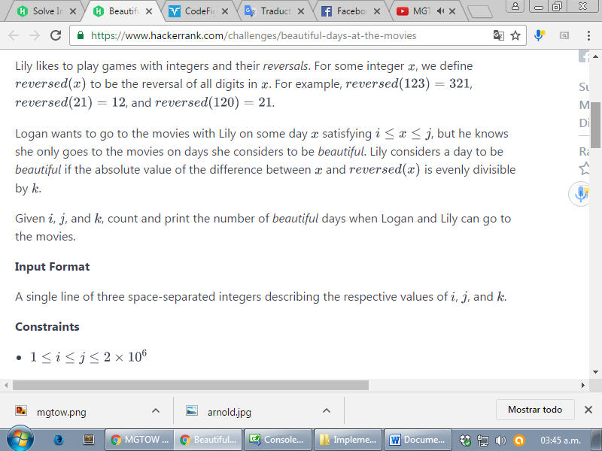

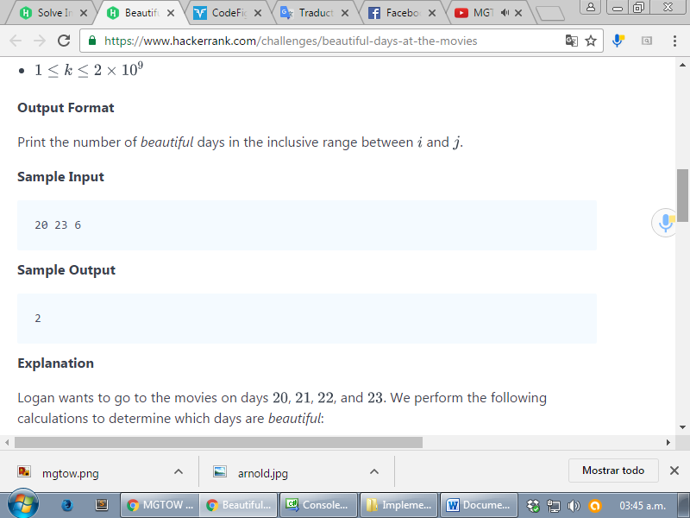

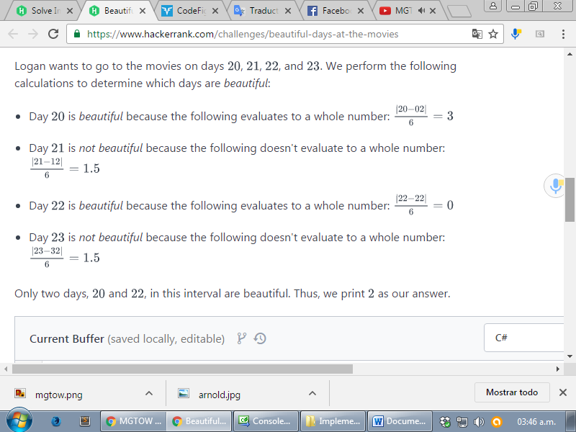

<https://www.hackerrank.com/challenges/beautiful-days-at-the-movies>

using System;

using System.Collections.Generic;

using System.Linq;

using System.Text;

namespace ConsoleApplication1

{

class Program

{

static void Main(string[] args)

{

string[] input = Console.ReadLine().Split(' ');

int i = int.Parse(input[0]);

int j = int.Parse(input[1]);

int k = int.Parse(input[2]);

int ans = 0;

for (int n = i; n <= j; n++)

{

char[] rev = n.ToString().ToCharArray();

Array.Reverse(rev);

if (Math.Abs(n - int.Parse(new string(rev))) % k == 0)

{

ans++;

}

}

Console.WriteLine(ans);

Console.ReadLine();

}

}

}